**Junior Footy – Season 2021**

**THE REGISTRATION PROCESS**

**A Step by Step Guide**

Welcome / Welcome Back to the Ainslie Football Club (AFC).

**Need help to complete your registration?**

This *Step by Step Guide* is provided to assist you in correctly completing your player registration for season 2021.

Player registration is undertaken through the online registration system provided by the Sports Technology Group (Sports TG).

**Which process do I follow?**

The registration process that you will follow depends on which situation applies to you, specifically whether you:

* played Junior Football for Ainslie in 2020 *(returning junior football player - excludes Auskick, see below)*
* are a new player who has never played AFL before *(new player)*
* played AFL before but are new to Ainslie *(transferring player)*
* are transitioning to the Junior Football Program from the Auskick system *(transitioning player)*

The process will also depend on how many players you are registering. The available options are highlighted in **Attachments A** and **B**. For further information on the registration process relating to your personal situation click on the applicable option in the Attachments.

**More info**

SportsTG have a Frequently Asked Questions section available at <https://support.sportstg.com/help/registration-faqs-for-participants> to assist you.

**Still having trouble?**

If you still require assistance, please contact Simon Holt on 0423 060 061 or [simon.holt@ainsliefootball.com.au](mailto:simon.holt@ainsliefootball.com.au)

Regards

Junior Football Operations

Ainslie Football Club

January 2021

**Attachment A – Registering One Player**

*Click Here*

*Click Here*

*Click Here*

*Click Here*

**YESS**

***Click Here***

**NO**

**Attachment B – Registering Multiple Players**

**YES and NO**

*Click Here*

*Click Here*

*Click Here*

*Click Here*

*Click Here*

**YES**

**NO**

**Registering One Returning Player**

**Follow these instructions to register a single returning player. If you are registering multiple returning players or a returning player/s and a new player*****click here****.*

1. **Click on the link below to start the registration process. *This will take you to the screen below.***

[***https://membership.sportstg.com/regoform.cgi?aID=4117&pKey=25e0f82ef66194f80a7ccbf630b27cc7&cID=1373&formID=36056***](https://membership.sportstg.com/regoform.cgi?aID=4117&pKey=25e0f82ef66194f80a7ccbf630b27cc7&cID=1373&formID=36056)

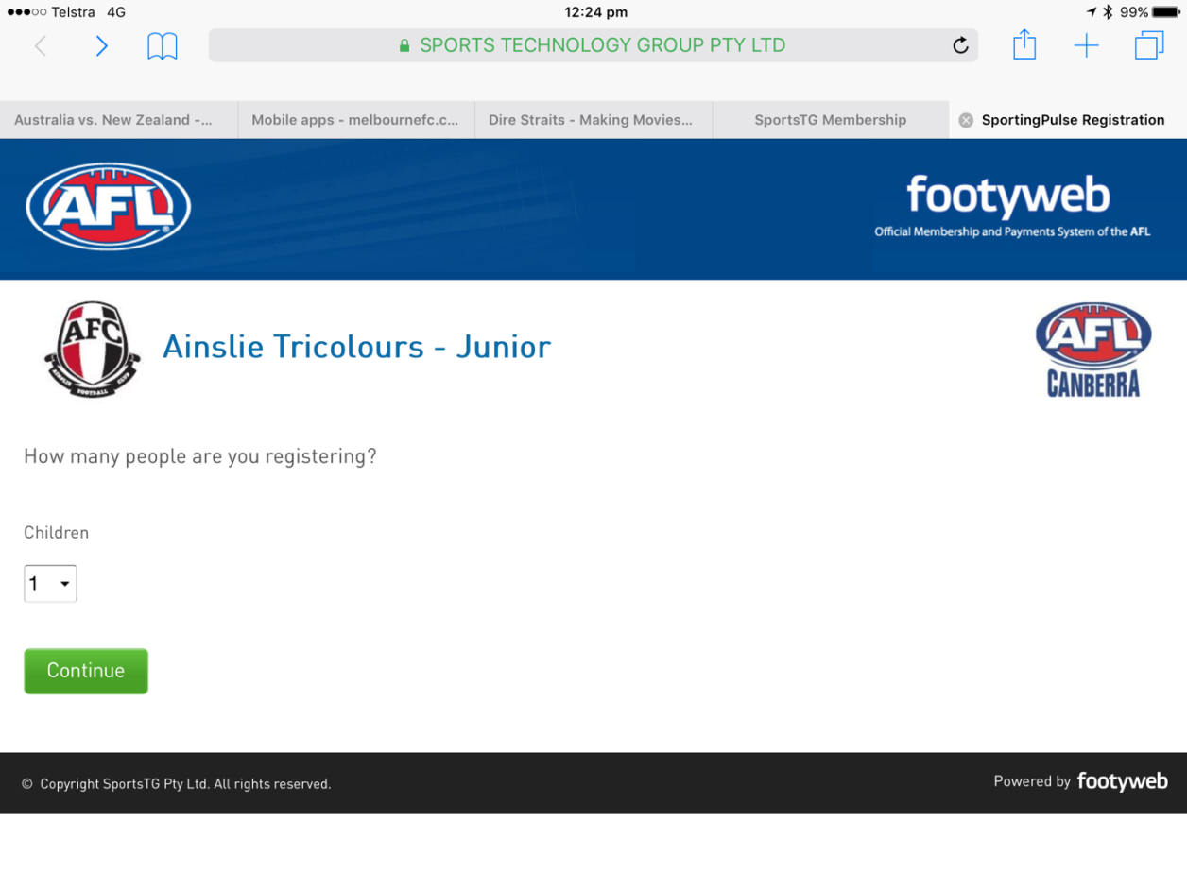

1. **To register one returning player select “Continue". *This will take you to the screen below.***

**NB: if you are registering multiple returning players or a returning player/s and a new player/s** ***click here*****.**

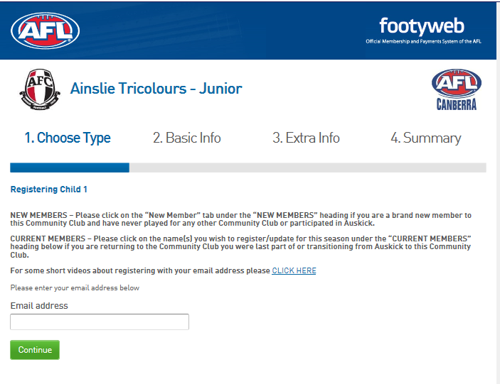

1. **Enter your email address and select “Continue”. *This will take you to the screen below.***

**NB: you must enter the email address that you have used to register your child in a previous season. If you are no longer using, have access to or remember that address please email the Junior Football Administrator at** [**lyn.parkinson@ainsliefootball.com.au**](mailto:lyn.parkinson@ainsliefootball.com.au) **with your new email address and player’s name and date of birth.**

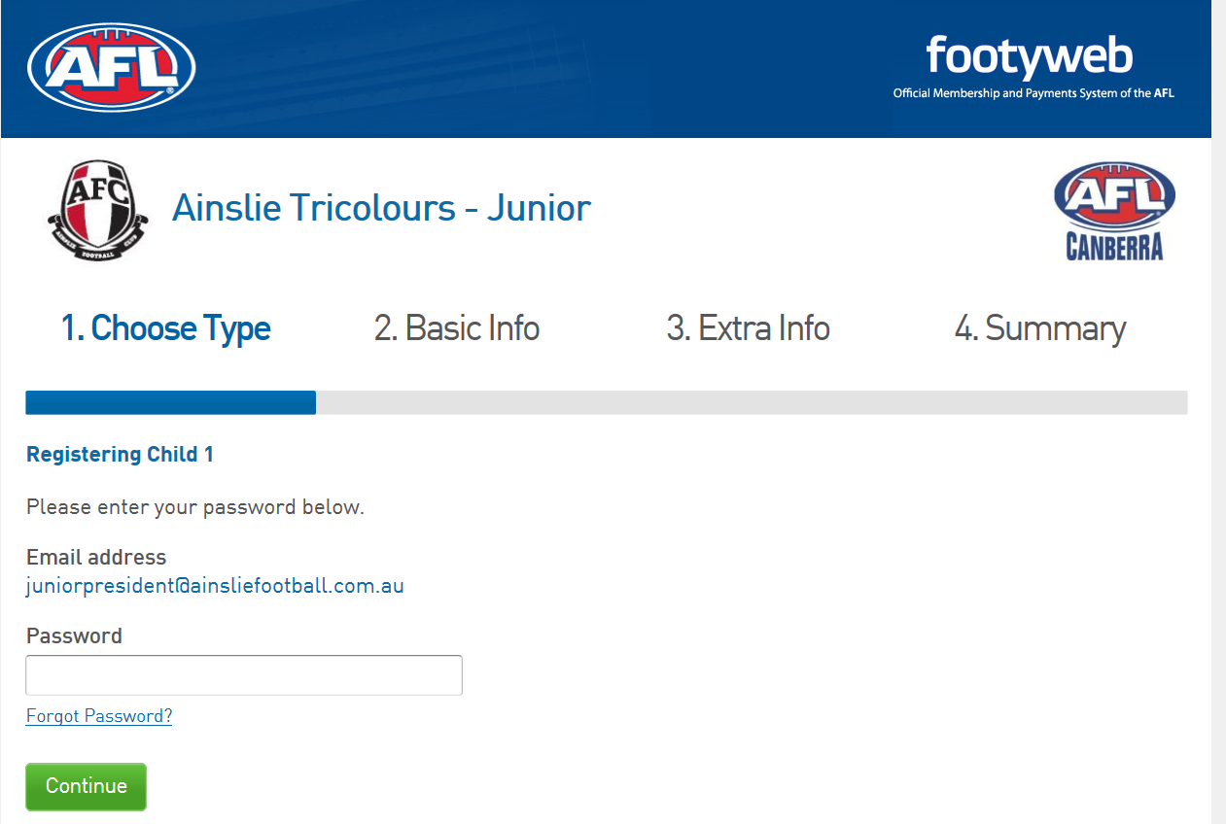

1. **Enter your password and select “Continue”. *This will take you to the screen below.***

**NB: If you have forgotten the password attached to your account, click on the “Forgot Password” link. This will take you through a process to reset your password so that you can resume the registration process. Follow the screen prompts to complete your registration.**

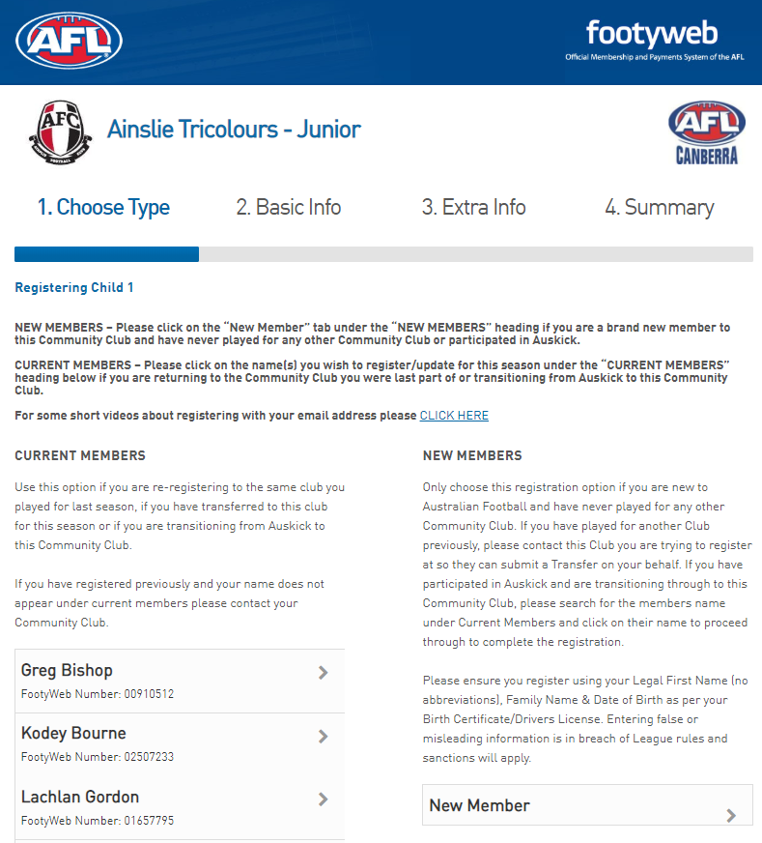

John Smith

**FootyWeb Number: 12345678**

1. **Because you are registering a returning player any players previously registered under the email address you are using will appear on this screen. Click on the player you are registering for the current year. *This will take you to the screen below.***

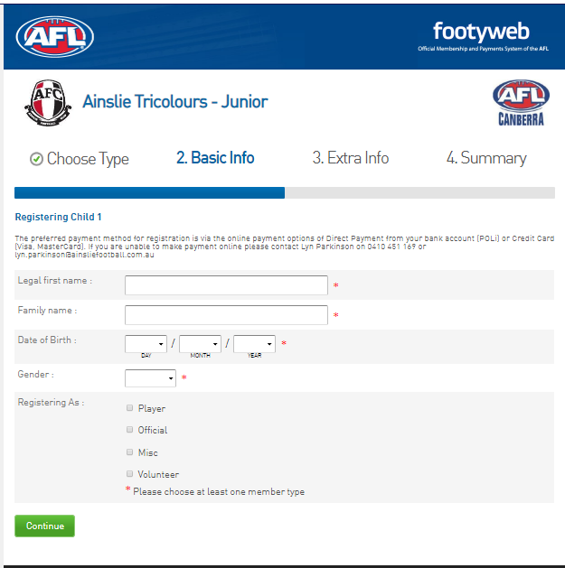

1. 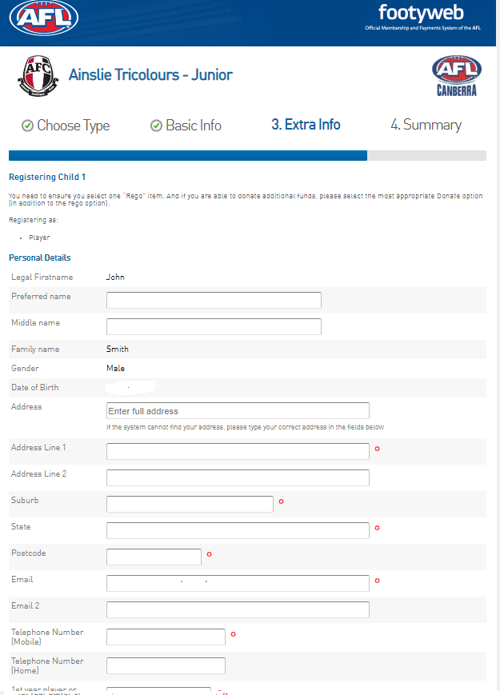**You are now ready to register your child. Complete all fields and remember to register your child as a “Player” every time you enter this page. Once you have finished completing the page select “Continue”. *This will take you to the screen below (note this is only a partial view of the full screen that will be shown for this stage of the registration process).***

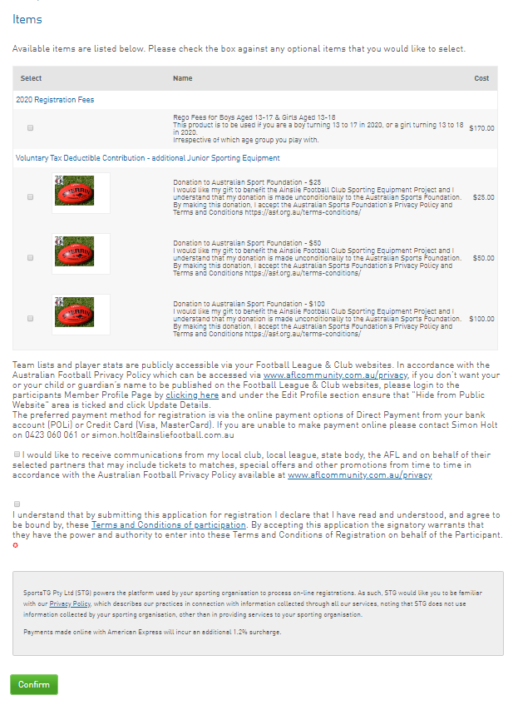

1. **Complete all fields and, under the “Items” section, remember to check the box that matches your registration (ie the age group that your player will play) and the box that confirms your acknowledgement of the “Terms and Conditions”. As applicable please also check the box that matches any Voluntary Tax Deductible Contribution that you may wish to make and the box confirming your desire to receive ongoing communications. Press “Confirm”. *This will take you to the screen below.***

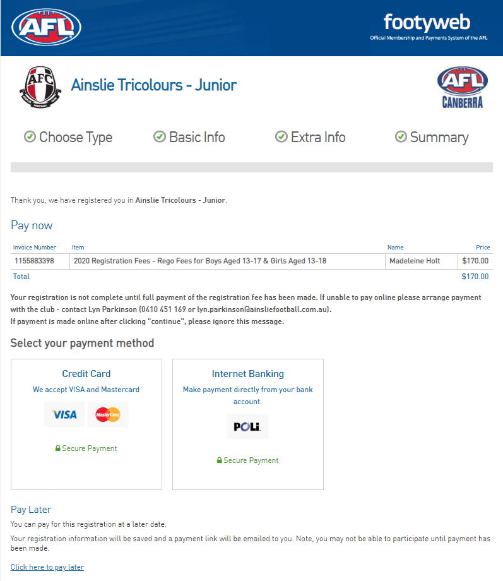

1. 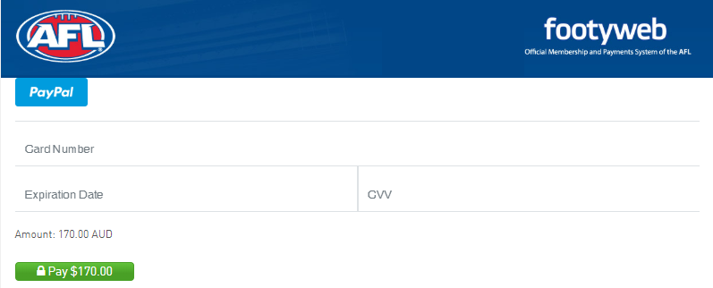**Click on your preferred payment option to pay your registration fees. *Selecting the “*Credit Card” option *will take you to screen a) below. Selecting the* “Internet Banking” option *will take you to screen b) below*.**

**a)**

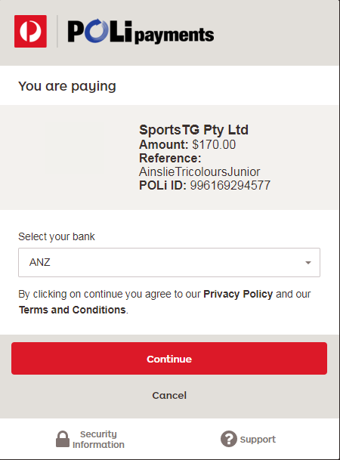

**b)**

1. **Follow the prompts on the relevant screen to finalise your payment and registration.**

**Registering One New Player**

**Follow these instructions to register a single new player who has not previously played AFL with Ainslie or another Club. If you are registering multiple new players or a new player and a returning player/s** ***click here*****.**

1. **Click on the link below to start the registration process. *This will take you to the screen below.***

[***https://membership.sportstg.com/regoform.cgi?aID=4117&pKey=25e0f82ef66194f80a7ccbf630b27cc7&cID=1373&formID=36056***](https://membership.sportstg.com/regoform.cgi?aID=4117&pKey=25e0f82ef66194f80a7ccbf630b27cc7&cID=1373&formID=36056)

1. **To register one new player select “Continue". *This will take you to the screen below.***

**NB: if you are registering multiple new players or a new player and a returning player/s** ***click here*****.**



1. **Enter your email address and select “Continue”. *This will take you to the screen below.***

**NB: Please make a note of the email address that you are using to register your new player as this will be required for future registrations.**

**NB2: If you have previously used this email address to register other children the Password Screen will appear. If this is the case, either follow the prompts to complete your registration or, if you need assistance,** ***click here*** **for information on Registering One Returning Player or** ***click here*** **for information on Registering Multiple Players as applicable to your circumstances.**

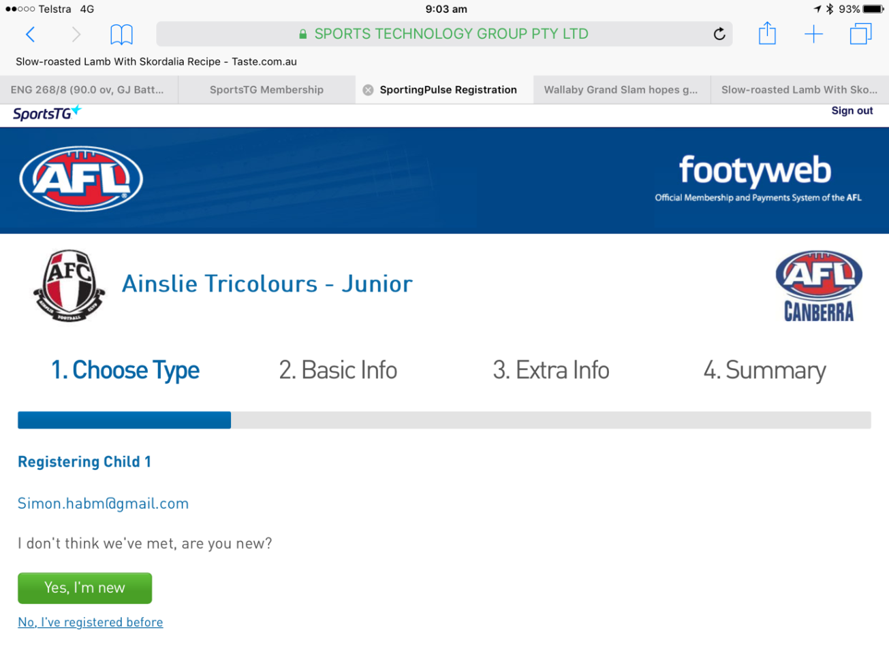

1. **For families registering for the first time, select “Yes, I’m new”. *This will take you to the screen below where you will get this message advising you to go to your inbox*.**

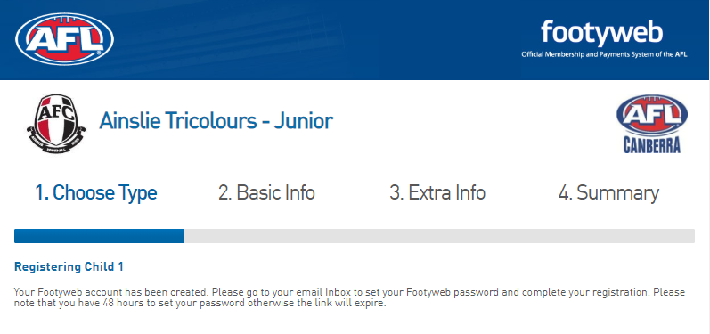

1. **Follow the instructions in the email to set up a password for your new SportsTG account. Specifically:**

* **click on the link “Click to Set Password” in the email and you will be taken to a webpage where you will set up your password**
* **once your password is set select the “Click here to continue” link. *This will take you to the screen below.***

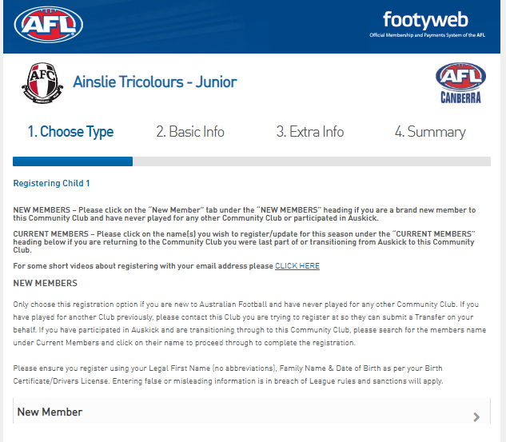

1. **Click on the “New Member” tab. *This will take you to the screen below.***



1. **You are now ready to register your child. Please complete all fields and remember to register your child as a “Player” every time you enter this page. Once you have finished completing the page select “Continue”. *This will take you to the screen below (note this is only a partial view of the full screen that will be shown for this stage of the registration process).***
2. **Complete all fields and, under the “Items” section, remember to check the box that matches your registration (ie the age group that your player will play) and the box that confirms your acknowledgement of the “Terms and Conditions”. As applicable please also check the box that matches any Voluntary Tax Deductible Contribution that you may wish to make and the box confirming you wish to receive ongoing communications. Press “Confirm”. *This will take you to the screen below.***



1. **Click on your preferred payment option to pay your registration fees. *Selecting the “*Credit Card” option *will take you to screen a) below. Selecting the* “Internet Banking” option *will take you to screen b) below*.**

**a)**

**b)**

1. **Follow the prompts on the relevant screen to finalise your payment and registration.**

**Registering Multiple Players**

**Follow these instructions to register multiple new, returning or new and returning players.**

1. **Click on the link below to start the registration process.**

****[***https://membership.sportstg.com/regoform.cgi?aID=4117&pKey=25e0f82ef66194f80a7ccbf630b27cc7&cID=1373&formID=36056***](https://membership.sportstg.com/regoform.cgi?aID=4117&pKey=25e0f82ef66194f80a7ccbf630b27cc7&cID=1373&formID=36056)

2

1. **Select the number of players you wish to register. You can register new and returning players in the same registration process. *This will take you to the screen below.***

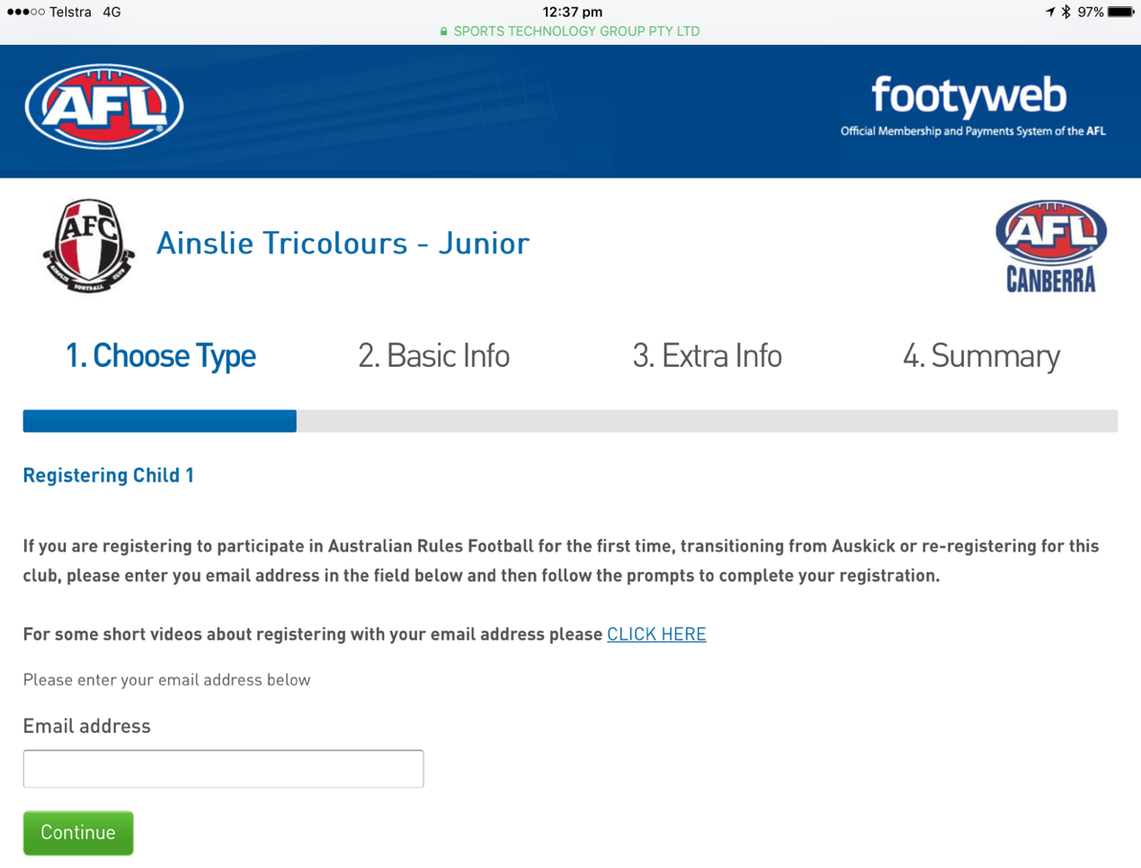

1. **Enter your email address. *This will take you to the screen below.***

**NB: for returning player registrations you must enter the email address that you have used to register your child in a previous season. If you are no longer using, have access to or remember that address please email the Junior Football Administrator at** [**lyn.parkinson@ainsliefootball.com.au**](mailto:lyn.parkinson@ainsliefootball.com.au) **with your new email address and the player’s name and date of birth.**

**NB2: for new player registrations please make a note of the email address that you are using to register your player as this will be required for future registrations.**



1. **Enter the password attached to your account and press “Continue”. *This will take you to the screen below.***

**NB: If you have forgotten the password attached to your account, click on the “Forgot Password” link. This will take you through a process to reset your password so that you can resume the registration process. Follow the screen prompts to complete your registration.**

**The screen will display the names of previously registered players.**

**NB2: If names are missing they will likely be linked to another email address.**

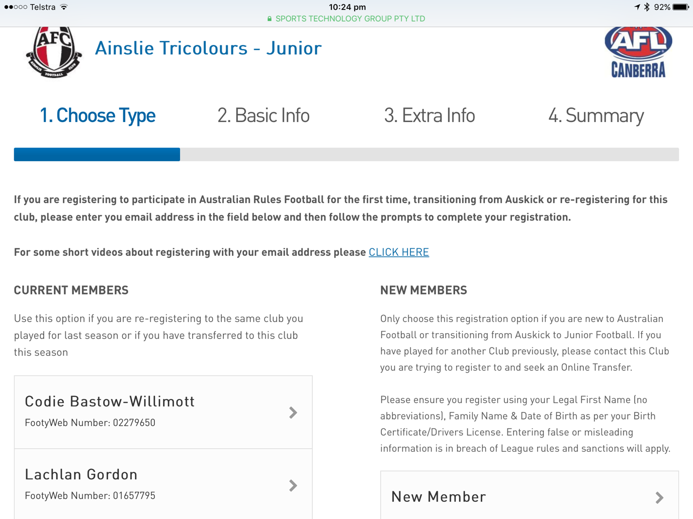

John Smith

**FootyWeb Number: 12345678**

Bill Smith

**FootyWeb Number: 22223688**

1. **If you are a current member (and are registering a player/s who has played with Ainslie previously) click on the first named player. If you are a new member (and are registering a player who has not previously played with Ainslie) select “New Member”. *Either of these selections will take you to the screen below.***



1. **You are now ready to register player #1. Please complete all fields and remember to register your child as a “Player” every time you enter this page. Once you have finished completing the page select “Continue”. *This will take you to the screen below (note this is only a partial view of the full screen that will be shown for this stage of the registration process).***



1. **Complete all fields and, under the “Items” section, remember to check the box that matches your registration (ie the age group that your player will play) and the box that confirms your acknowledgement of the “Terms and Conditions”. As applicable please also check the box that matches any Voluntary Tax Deductible Contribution that you may wish to make and the box confirming you wish to receive ongoing communications. Press “Confirm”. *This will take you to the screen below.***

**NB: because you are registering more than one player the system will take you back to the following screen to select the additional player prior to moving to the payment screen.**

Bill Smith

**FootyWeb Number: 22223688**

John Smith

**FootyWeb Number: 12345678**

1. **Click on the second named player and complete the same process as previous for player #2. Press “Continue”. *This will take you to the screen below.***



**Registering Child 2**

1. **Complete the same process for player #2 as outlined in 7. above and press “Continue”. *This will take you to the screen below.***



1. **Click on your preferred payment option to pay your registration fees. *Selecting the “*Credit Card” option *will take you to screen a) below. Selecting the* “Internet Banking” option *will take you to screen b) below*.**

**a)**



**b)**

1. **Follow the prompts on the relevant screen to finalise your payment and registration.**

**Registering an Auskick Player Transitioning to Junior Football**

**Follow these instructions to register an Auskick Player who is transitioning to Junior Football.**

1. **Click on the link below to start the registration process.**

****[***https://membership.sportstg.com/regoform.cgi?aID=4117&pKey=25e0f82ef66194f80a7ccbf630b27cc7&cID=1373&formID=36056***](https://membership.sportstg.com/regoform.cgi?aID=4117&pKey=25e0f82ef66194f80a7ccbf630b27cc7&cID=1373&formID=36056)

1. **Select the number of players you wish to register. *This will take you to the screen below.***



1. **Enter your email address. *This will take you to the screen below.***

**NB: Please make a note of the email address that you are using to register your child as this will be required for future registrations.**



1. **Enter the password attached to your account and press “Continue”. *This will take you to the screen below.***

**NB: If you have forgotten the password attached to your account, click on the “Forgot Password” link. This will take you through a process to reset your password so that you can resume the registration process. Follow the screen prompts to complete your registration.**



1. **Click on “New Member”. If you have previously registered as an Auskick player *this will take you to the screen below.***



1. **Complete all fields and remember to register your child as a “Player” every time you enter this page.**

**NB: As you enter the player’s name and date of birth a red box highlighting previous registrations for your email address will appear as shown on the screen below.**

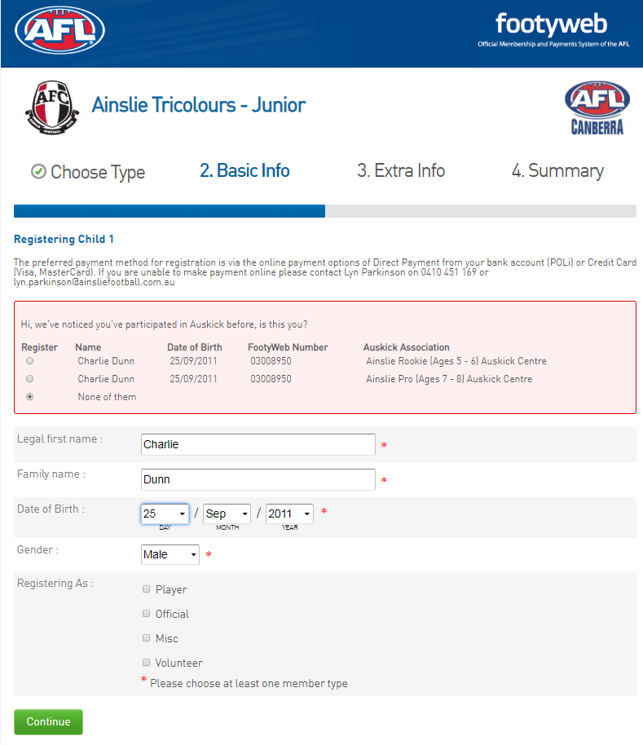

1234567

John Smith

1234567

John Smith

1. **Click on the relevant option and finish completing all fields - remember to register your child as a “Player” every time you enter this page. Once you have finished completing the page select “Continue”. *This will take you to the screen below (note* t*he following is only a partial view of the full screen that will be shown for this stage of the registration process).***



1. **Complete all fields and, under the “Items” section, remember to check the box that matches your registration (ie the age group that your player will play) and the box that confirms your acknowledgement of the “Terms and Conditions”. As applicable please also check the box that matches any Voluntary Tax Deductible Contribution that you may wish to make and the box confirming you wish to receive ongoing communications. Press “Confirm”. *This will take you to the screen below***



1. **Click on your preferred payment option to pay your registration fees. *Selecting the “*Credit Card” option *will take you to screen a) below. Selecting the* “Internet Banking” option *will take you to screen b) below*.**

**a)**



**b)**

1. **Follow the prompts on the relevant screen to finalise your payment and registration.**

**Transferring to Ainslie from another Club**

**Online registration is not available to players transferring to the Ainslie Football Club (AFC) from another Club (locally or from interstate) until after their registration has been transferred from their former Club. This generally won’t be until 1 February or later (this is an AFL rule), but this doesn’t prevent you from starting the transfer process now.**

**Players wishing to initiate a transfer to the AFC must complete the following steps:**

1. **Email the AFC General Manager, Simon Holt, at simon.holt@ainsliefootball.com.au with your full name, date of birth, name of last Club and number of years played with that Club**
2. **At the same time, make contact with your former Club and advise them of your intention to transfer to Ainslie. This is a courtesy that all Clubs extend to each other when a transfer is proposed. In some circumstances a Club representative may make contact with you regarding your reason(s) for changing Club.**
3. **Email Simon when you have advised your former Club and he will also send that Club a courtesy email. Assuming there are no issues, Simon will:**

* **process your transfer through the SportsTG system**
* **notify you when your transfer has been processed**

**Should there be any issues with your proposed transfer Simon will contact you.**

1. **Once your transfer has been processed (from 1 February) you will be able to access the online registration system and complete your registration. If, as part of this process, you are registering :**

* **a single ‘new-to-Ainslie’ player** ***click here***
* **multiple ‘new-to-Ainslie’ players** ***click here***
* **a ‘new-to-Ainslie player’ and a returning Ainslie player** ***click here***